Mtandika (Michael Agius reported in November 2016)
At Mtandika the Trade School is going from strength to strength and Sister Barberina is applying for formal Government registration, through the Government’s VETA [Vocational Education and Training Authority]. However this means :

• the school needs certain standards of equipment for courses eg electrical sewing machines, as well as treadle ones which they already have and more computers.
• Sister has had to start courses for boys as well as girls, so has started an electrical engineering course and wants to start one in building construction. This will necessitate the building of a boy’s dormitory, as well as buying equipment and materials for the boy’s courses.

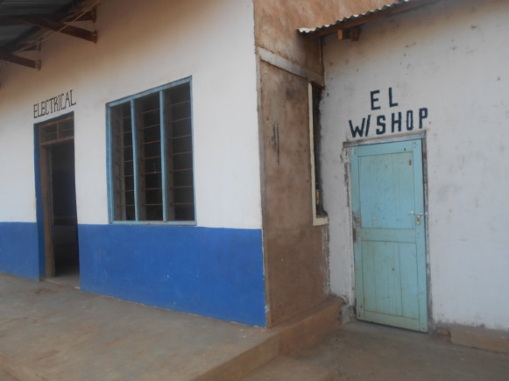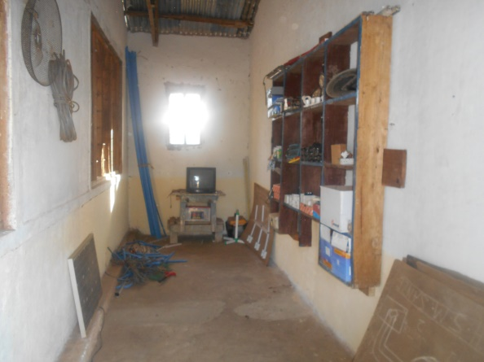
Electrical classroom and workshop Electrical workshop

In addition, works that VETA have requested to be carried out at the Trade School include enlarging the classroom for the electrical course, building an electrical store, converting the main hall to provide a classroom for the construction course, redecorating the main hall, building a canteen for day students, constructing shelves for the new library building, building a workshop store, making tables and desks for the electrical and construction courses, repairing the girls dormitories, redecorating classrooms and providing a new tailoring workshop. These works are ongoing and VETA’s formal decision is awaited.

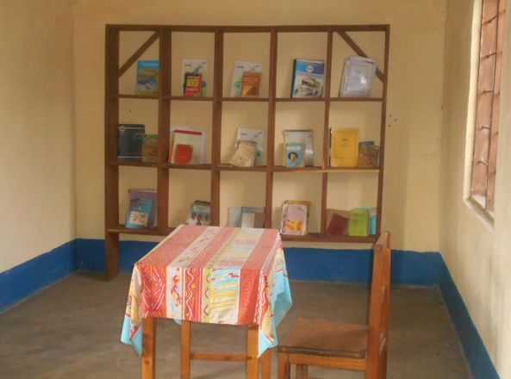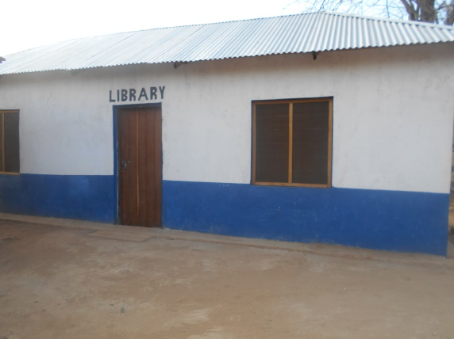
New library shelves New library building

Apart from that the Trade School continues to give some 30 girls a broad based education, which as well as teaching them Tailoring skills now includes English, Maths and Computer Studies. In addition they still have to help cultivating the shambas [allotments] growing the maize, cassava and vegetables that form their basic diet, as well as helping prepare and cook meals.

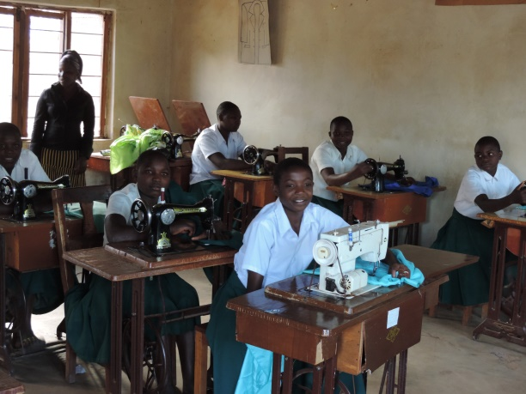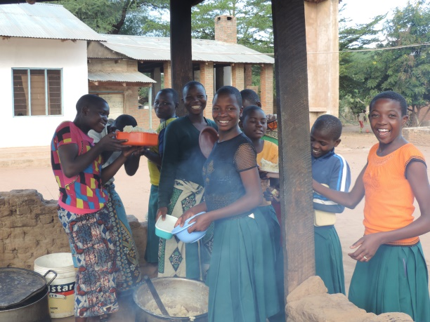
Sewing class Cooking maize

The solar pump is working well and as well as supplying the School, provides enough water to irrigate the shambas. Last year the distribution of water to the girls ablution blocks and essential rooms around the compound have been improved.

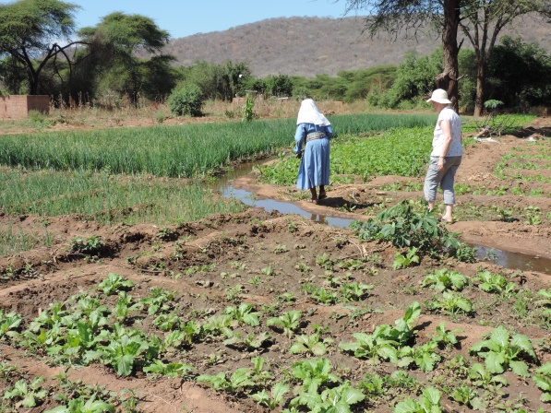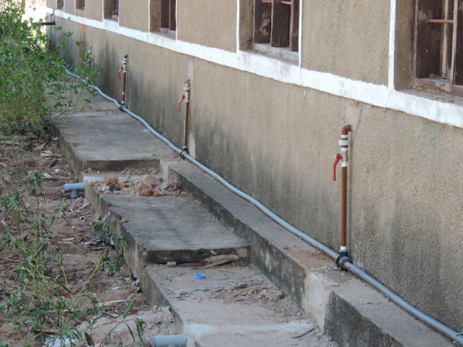
Irrigated shambas Water distribution pipework

In addition to the older Trade School girls, Sister looks after ten orphans from about 12 years old down to 6 years, who all go to the village Primary School. One of these, Almininata, is a rising star and consistently top of her class.

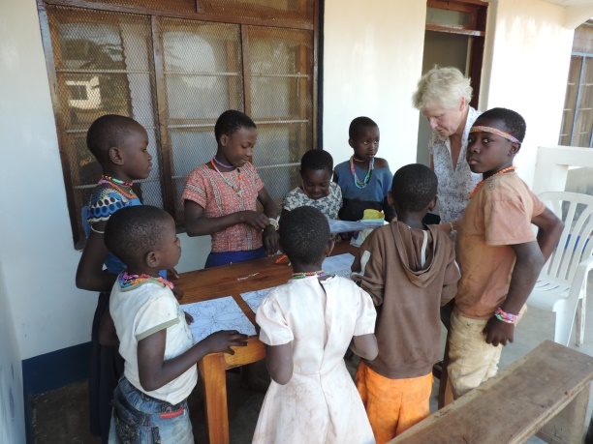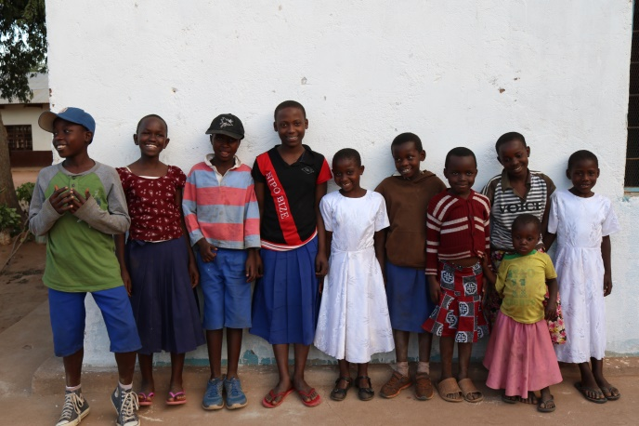
Mary with the orphans The orphans, with Alminata fourth from left

Away from the Trade School itself, funding has also been given to re-roof the local convent where the rest of Sister Barberina’s Community lives. The original roof blew off in a gale and the nuns were left living open to the elements for many months until temporary cover could be provided. During this period a lot of weather damage occurred to the inside of the building.

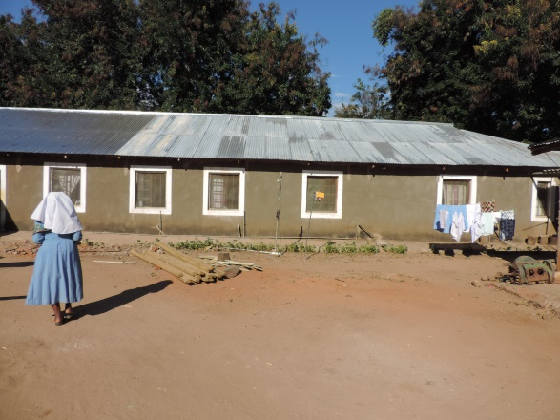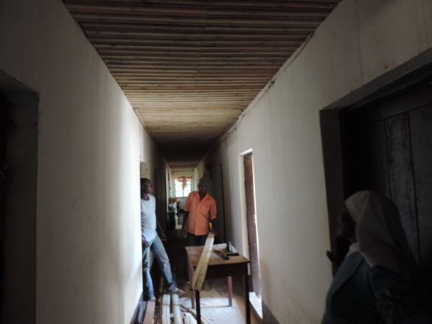

The new Convent roof Internal works in the Convent

